The following screenshots have all been taken from my Page Replacement Simulation Program, which can also be found in the zip folder this document was stored in.

**Answers:**

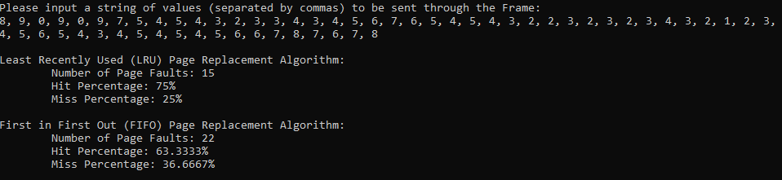

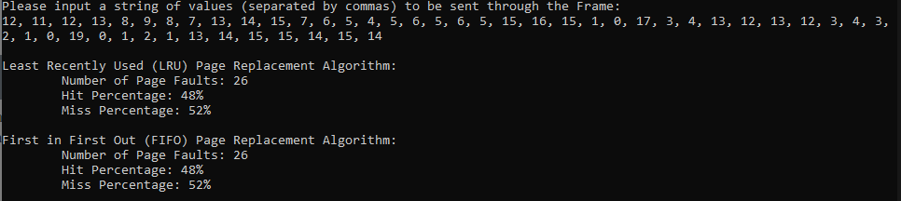

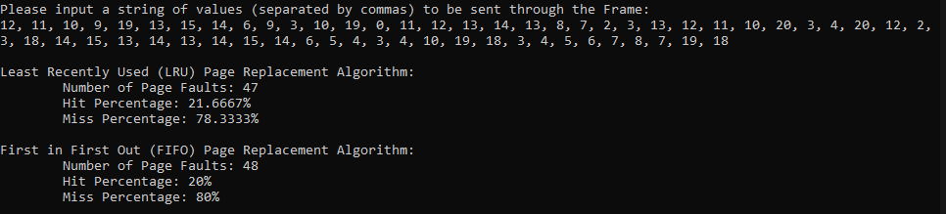

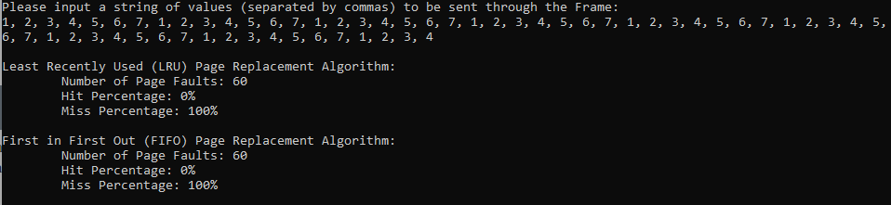

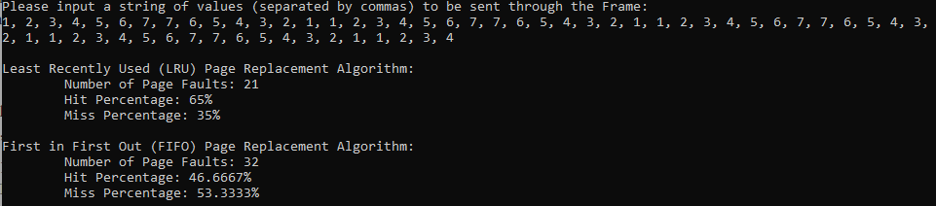

**Analysis:**

Based on the data sets that I was provided with for this assignment, it would appear as though the Least Recently Used (LRU) Page Replacement Algorithm would be more effective than the First in First Out (FIFO) Page Replacement Algorithm. This is because although the two performed at the same level in Questions 2 and 4, LRU tended to receive more hits than FIFO did on Questions 1, 3, and 5, which would indicate, at least with these data sets, that LRU would be the better page replacement algorithm. However, between the two, FIFO was conceptually much easier to program because all I needed to do was create a variable that kept track of which element in the array (“frame”) was at the front of the queue. On the other hand, I was able to implement LRU by constantly shuffling the elements around in the array based on when they were most recently accessed by the system. Needless to say, this meant that LRU required significantly more processing power in my program, but based on the data, would have actually processed the data faster than FIFO if it was an actual computer’s Virtual Memory because it generally wouldn’t have needed to pull the data as frequently from its RAM as the FIFO algorithm would have required.